Name: Devansh Shah Roll Number: 1914078 Batch: B2

Inlab: Execution of object relational queries

# Defining Types

CREATE TYPE PointType AS(

x int, y int

);

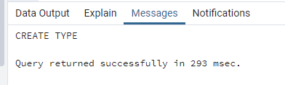

CREATE TYPE LineType AS(

end1 PointType,

end2 PointType

);

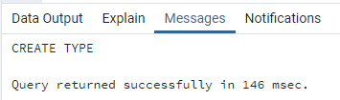

# Creating Table using object types and basic datatypes

CREATE TABLE Lines(

lineid int PRIMARY KEY,

line LineType,

dist float

);

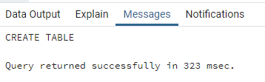

# Declaring Function

CREATE FUNCTION distance(x1 integer,y1 integer,x2 integer,y2 integer)

RETURNS float AS $$

BEGIN

RETURN sqrt(power((x2-x1),2)+power((y2-y1),2));

END;

$$ LANGUAGE plpgsql;

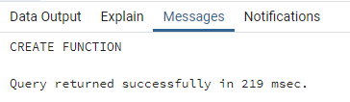

# Constructing object values by inserting values

INSERT INTO Lines Values(1,((0,0),(5,5)),distance(0,0,5,5)),(2,((4,5),(7,8)),distance(4,5,7,8)),

(3,((6,2),(8,6)),distance(6,2,8,6));

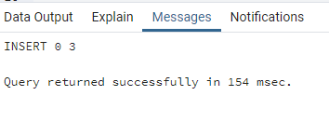

# Displaying data

SELECT * FROM Lines;

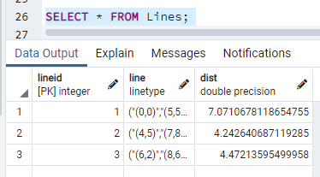

SELECT lineid,((Lines.line).end1) ,((Lines.line).end2) FROM Lines;

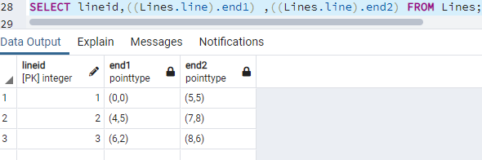

# Dropping Types

DROP Table Lines;

DROP TYPE LineType;

DROP TYPE PointType;

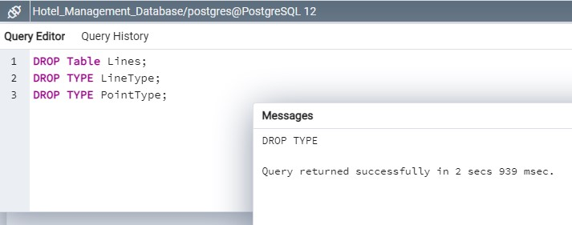

We need to drop the table first or else drop type will return error as table will be still be using it. We can either go with drop and cascade if we don’t want to drop the table.